Appendix C: Leadership Structure within HLP

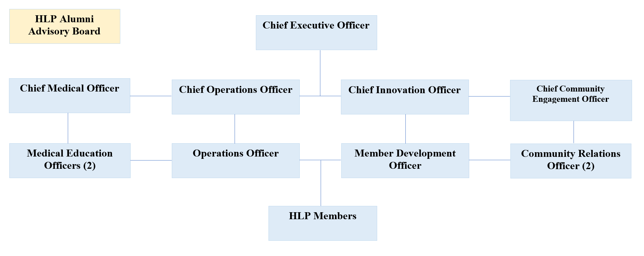

Member Development Officer: Responsibilities for this officer include the recruitment process of new first year medical students into HLP. This includes outreach to the class informing them of the Designated Emphasis, creating/updating the application, and coordinating and conducting interviews with the candidates. This is also the point-person in leading post-interview discussions about applicants. Throughout the year, this person will maintain connections with the first year HLP cohort to ensure they are engaged and satisfied with the curriculum.

Chief Operations Officer and Operations Officer: The responsibilities of these officers include scheduling and planning team building and professional development events through the administration. These officers also act as the main liaisons between HLP and other organizations either on campus or in the Inland Empire. These officers are also responsible for acting as the program’s main point of contact for logistics such as pitching ideas to the Medical Student Council or Education Fund for HLP monetary needs and any logistical action items other branches of HLP leadership may need implemented.

Chief Medical Education Officer and Medical Education Officers: The responsibilities for these officers include developing and leading the curriculum for the first and second year cohorts. This includes organizing speakers and activities to fulfill the 10-lecture requirement per year, and ensuring the curriculum is developed in an organizational flow that complements the previous lectures to promote professional growth of HLP members throughout the year. Outside of HLP, these roles work closely with the Medical Education Council and UCR administration to develop and enhance the curriculum.

Chief Community Engagement Officer and Community Engagement Officer: Responsibilities for these officers include figuring out where new HLP members interests’ lie to help establish the new general members’ projects. The officers in these roles will help form tangible goals, chart out desired outcomes, and identify potential issues with projects. Once the projects are established, these roles will continue to monitor their progress. These officers are also responsible for ensuring that all new first year cohort members are assigned to appropriate mentors and follow up on mentorship progress. These officers are also responsible for connecting with community leaders to expand the HLP presence and network.

Chief Innovation Officer: This officer will have completed the National Science I-Corps Program offered through the Entrepreneurial Proof of Concept and Innovation Center and their main responsibilities include facilitating knowledge about the fundamentals of innovation and entrepreneurship in the first and second year curriculum. This officer also assists the Community Engagement team in working out logistics of and solidifying passion projects for the new cohorts.

Chief Executive Officer: This officer is responsible for overseeing all aspects of the HLP, including the rest of the executive board. They are responsible for implementing HLP’s mission into the program and constantly finding new ways to grow and improve the program. The CEO works closely with School of Medicine administration to solicit advice and guidance in working towards HLP goals. They work closely with the Chief Operations Officer for administrative needs including, but not limited to, budget finalization, Designated Emphasis establishment, and ensuring that all members are meeting their requirements. They are also responsible for running all biweekly meetings and helping keep the team on task in working towards collective goals. The CEO is also responsible for helping assess and correct any concerns students may be having about the program and addressing any needs that may come up.

